Manual Wheelchair & Specialist Buggy Referral Form
REWS (Rotherham Equipment & Wheelchair Service)

This form should be completed and signed by the patient’s Healthcare Professional.
(For persons with terminal illness or long-term disability of 6 months or longer.)
Please complete ALL sections fully. Failure to do so will result in delays processing the request.

For Powered Chairs Please Complete Powered Wheelchair Referral Form.

Patient’s Personal Details
Title |  | Gender | Male Female
Surname
Forename(s) |  | Date of Birth
Preferred Name |  | NHS Number
Home Address |  | Delivery Address
Post Code |  | Post Code
Tel No. |  | Contact
Mobile No. |  | Tel No.
Email Address |  | Main Language
Ethnic Origin |  | Religion
Disability
Relevant Medical Details
Critical Case (e.g. terminal illness) Yes No
Essential for hospital discharge? Yes No Date
Is this person already in possession of an NHS wheelchair? Yes No

Details of GP
Name |  | Address
Tel No.
CCG |  | Post Code

Details of Prescriber
Print Name |  | Address
Tel No.
Profession |  | Post Code
Would you like to be present at the assessment? Yes No
Signature |  | Date
Assessment Details: Wheelchair
What is the person’s walking ability within the home?
What is the person’s transfer method?
How often will the wheelchair be used?
Does the person need to sit in the wheelchair when travelling in transport |  |  | Yes No

Assessment Details: Cushion
Is a standard foam cushion adequate? | Yes No If yes:
Suggested cushion?
What is the maximum duration the person
will sit in the wheelchair in one session?
Can the person maintain sitting balance in the wheelchair? | Yes No
Person’s tissue status:
Previous sore(s): Yes No | Present sore(s): Yes No
Site Grade | Site Grade
Continence status:
Who will maintain and monitor cushion? | Waterlow score

Type Required
Non-Powered Wheelchair:
Person has limited walking ability, likely to be in excess of six months or is terminally ill.
Self Propelling |  | Attendant Push Chair

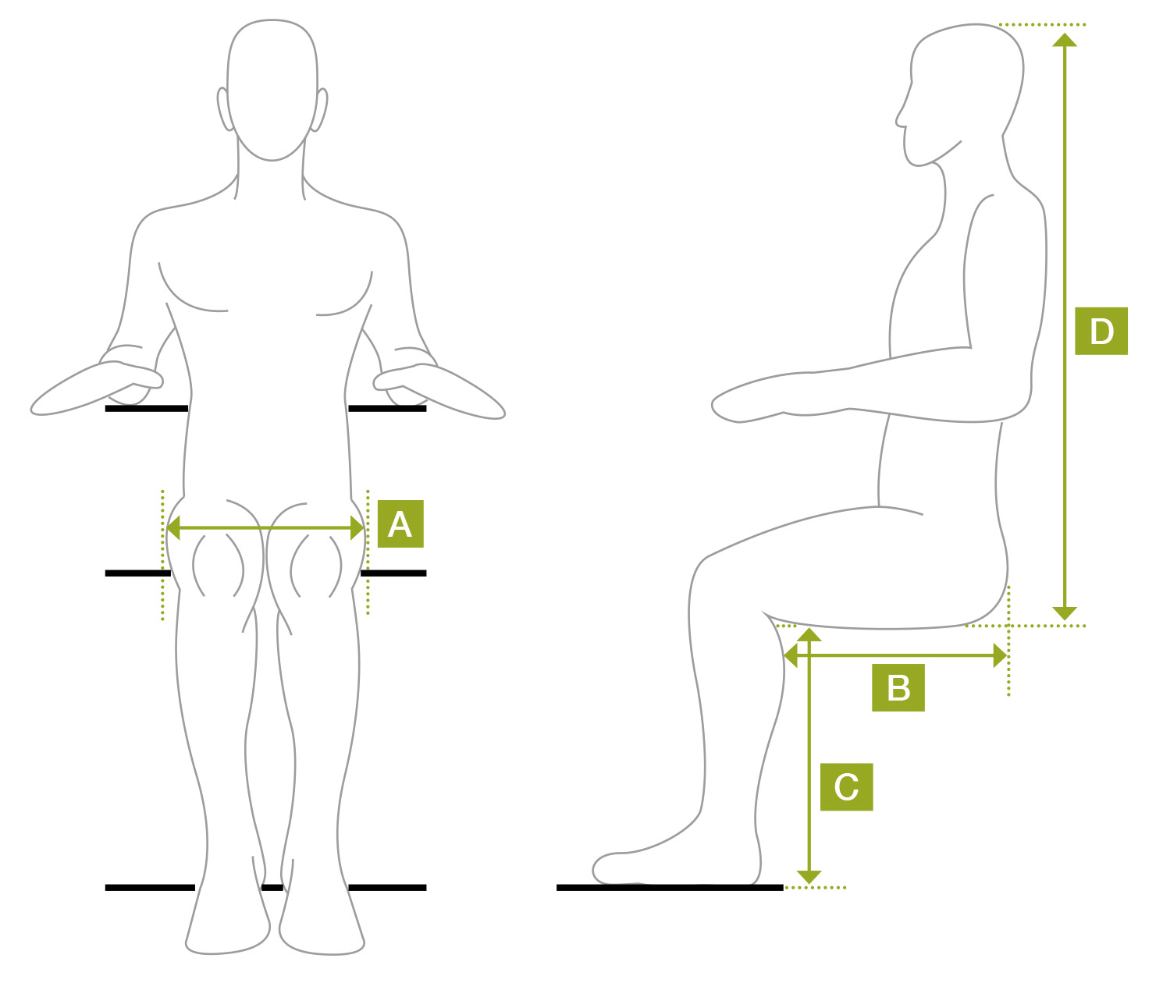
Measurements
Height
Weight
A = Hip width | cms  960413 Iss1 Online – Manual & Specialist  ins
B = Back of buttocks  to back of knee | cms  ins
C = Back of knee to  sole of foot | cms  ins
D = Seat to top of head | cms  ins

Further Assessment by REWS
Is further assessment required by REWS? | Yes No | Interested in Personal Wheelchair Budget? | Yes No
Referrer would like to be present at assessment? | Yes No

For Powered Chairs Please Complete Powered Wheelchair Referral Forms in Conjunction With Therapist or Specialist Nurse. We Do Not Provide Scooters or Powered Chairs For Outdoor Use Only.

Other Relevant Information To Support Your Assessment
(e.g. Posture, Home Environment, Carer Details)

PLEASE RETURN TO:
Rotherham Equipment Wheelchair Service
Eastwood Trading Estate
Chesterton Road
Rotherham
S65 1SX
Tel: 01709 916889
Fax: 01709 263296
Email: cabsl.rotherhamwheelchairservices@nhs.net

